Data Visualisation: Online Food Delivery Dashboard
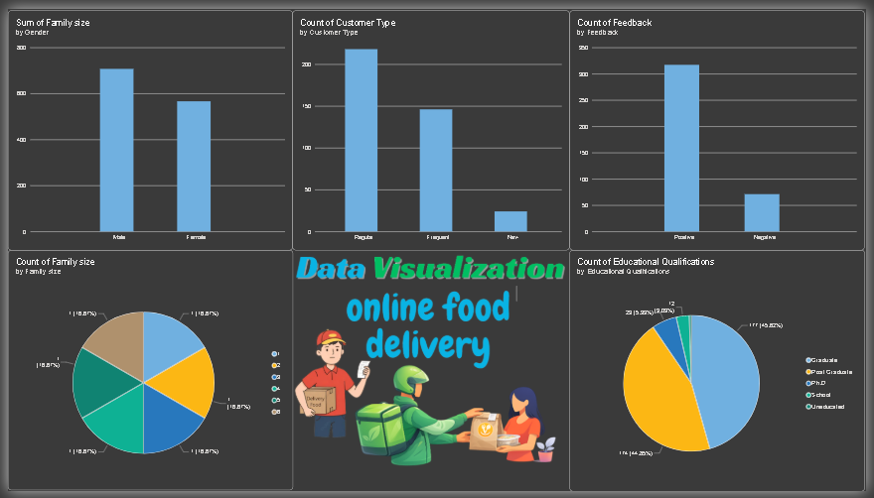

Key Insights
- Education Demographics: Graduate customers form the largest educational group, followed by Post Graduates.
- Family Size Distribution: Customer family sizes vary from 1 to 6, with the report showing the distribution across these family-size groups.
- Gender Participation: Male and female customers are both represented in the dataset, allowing comparison of customer participation by gender.
- Customer Loyalty & Engagement: The Regular, Frequent, and New customer categories provide a useful view of customer engagement and loyalty.
- Customer Sentiment: Positive feedback is substantially higher than negative feedback, indicating generally favorable customer responses.

